**Downloading weather data**

We now know enough to proceed with extracting information about the local weather from the National Weather Service website. The first step is to find the page we want to scrape. We'll extract weather information about downtown San Francisco from this page.

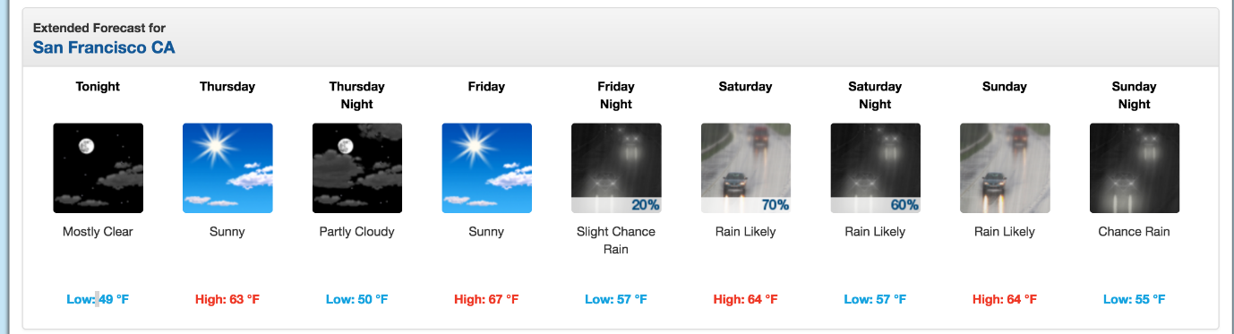

We'll extract data about the extended forecast.

As you can see from the image, the page has information about the extended forecast for the next week, including time of day, temperature, and a brief description of the conditions.

**Exploring page structure with Chrome DevTools**

The first thing we'll need to do is inspect the page using [Chrome Devtools](https://developer.chrome.com/devtools). If you're using another browser, [Firefox](https://developer.mozilla.org/en-US/docs/Tools/Web_Console/Opening_the_Web_Console) and [Safari](https://developer.apple.com/safari/tools/) have equivalents. It's recommended to use Chrome though.

You can start the developer tools in Chrome by clicking View -> Developer -> Developer Tools. You should end up with a panel at the bottom of the browser like what you see below. Make sure the Elements panel is highlighted:

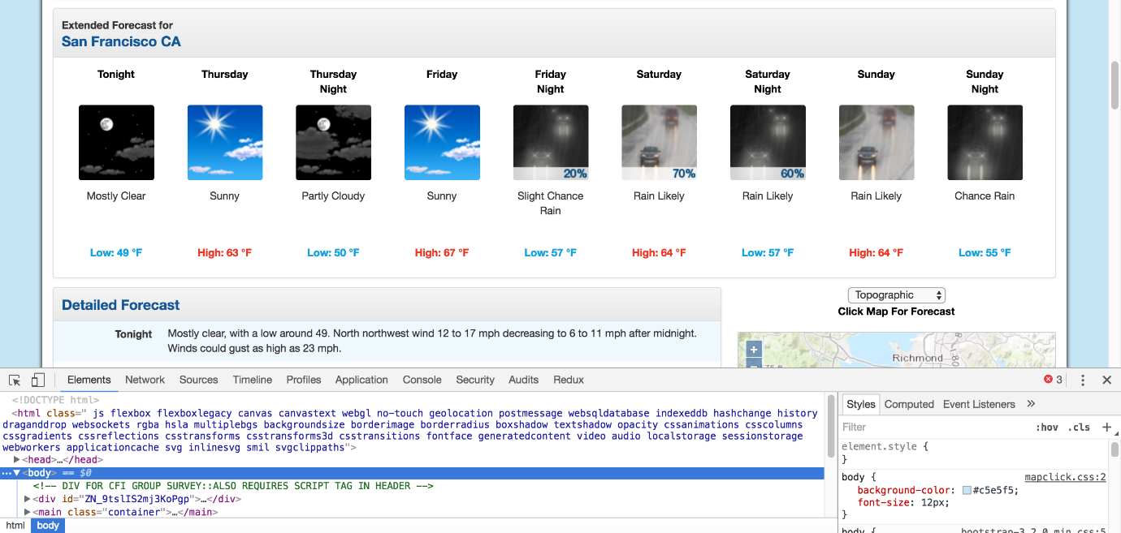

hrome Developer Tools.

The elements panel will show you all the HTML tags on the page, and let you navigate through them. It's a really handy feature!

By right clicking on the page near where it says "Extended Forecast", then clicking "Inspect", we'll open up the tag that contains the text "Extended Forecast" in the elements panel:

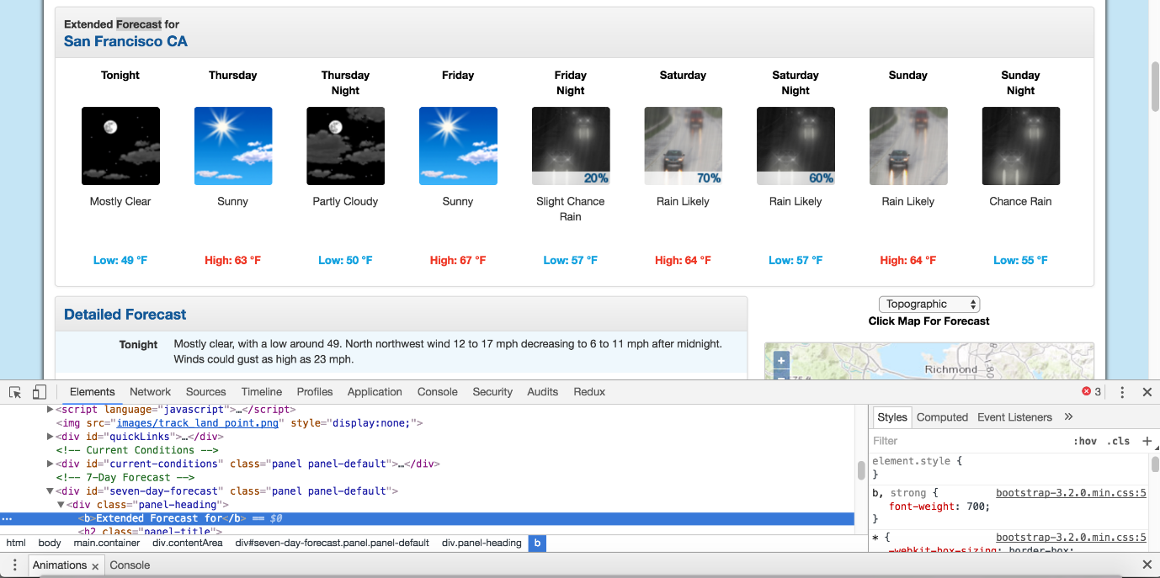

The extended forecast text.

We can then scroll up in the elements panel to find the "outermost" element that contains all of the text that corresponds to the extended forecasts. In this case, it's a div tag with the id seven-day-forecast:

The div that contains the extended forecast items.

If you click around on the console, and explore the div, you'll discover that each forecast item (like "Tonight", "Thursday", and "Thursday Night") is contained in a divwith the class tombstone-container.

T o download the page and start parsing it. In the below code, we:

* Download the web page containing the forecast.
* Create a BeautifulSoup class to parse the page.
* Find the div with id seven-day-forecast, and assign to seven_day
* Inside seven_day, find each individual forecast item.
* Extract and print the first forecast item.

**News articles**

**Sports scores**

**Weather forecasts**

**Stock prices**